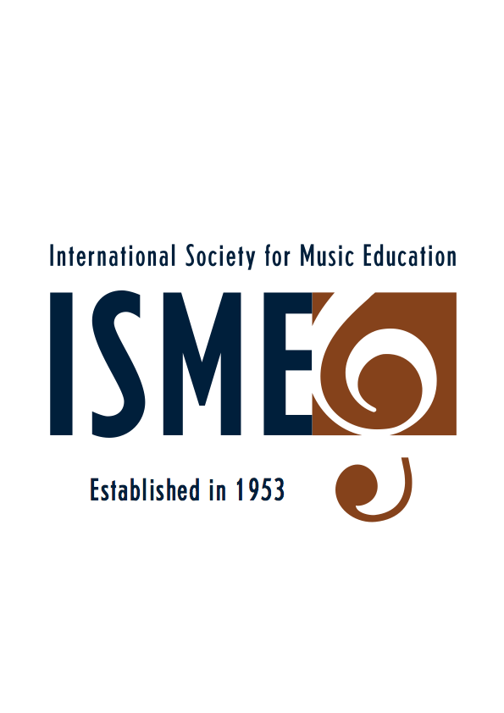
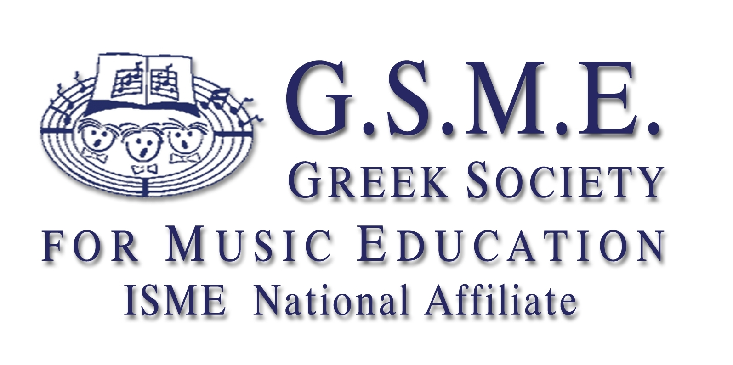
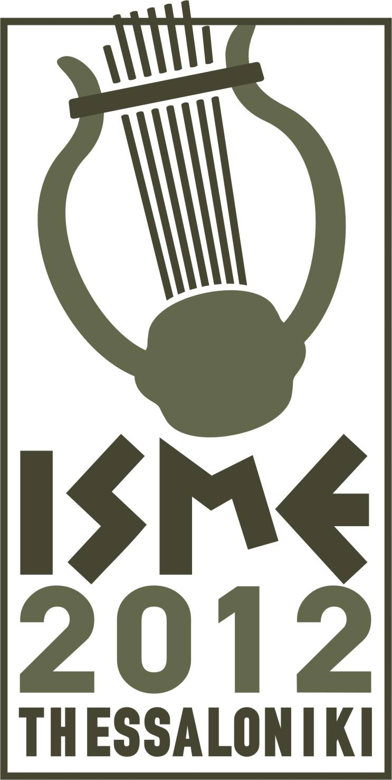
30th ISME World Conference on Music Education
Thessaloniki, Greece, July 15-20, 2012
www.isme.org

15th Early Childhood Music Education (ECME)
INTERNATIONAL SEMINAR, 9–13 July 2012, Corfu, Greece
Passing on the flame:
Reflecting on the Past
Envisioning towards the Future of Early Childhood Music Education

Song sharing sessions ECME seminar Greece, Corfu 9-13 2012
May 9, 2012

Dear participant,

The ECME commission is looking forward meeting you in Corfu for the 2012 Conference! During the conference we like to start the day with singing: sharing songs from all over the world.
We are wondering if you, as a participant of the conference, are willing to send us a song from your country/culture that is suitable for use with children from 0-8 years. Of course some songs are more suitable for younger children and other songs are more appropriate for children 4-8 years. It is important that the song is free of copyright!

We would like to ask you to give information about:
- Composer/nation/culture
- suitable for: exact age group children
- the original text and the transcription into Latin characters
- a free translation of the text into English
It would be great if you would attach a description of (musical) activities and/or games you can play with the children using the song. Variations in games i.e. for different age groups are also nice to describe. In this way we can pass on songs, games and musical activities from all over the world!

Conference participants also like to have all the songs available in a song book.
To be able to make a conference songbook I would like to ask you to send your song, game and/or activity to: v_gestel@hotmail.com before June 10, 2012. A copy of the song can be sent (as a picture in word or jpg or adobe) and will be transferred into a SIBELIUS score for printing.

Be sure the information you send to me includes:
- a clear copy of the song
- name of composer (if it is a traditional song indicate: traditional)
- intended age group children
- translation in English
- description of the game or suitable music activity

As the commissioner in charge of the song sharing sessions I would like to know whether you like to present your song during one of the sessions! (time allocated: maximum of 4 minutes) Please consider this opportunity and let me know of your interest in doing so.

Feel free to contact me if you have any questions or need further information.
I look forward seeing you at the beautiful island of Corfu.

On behalf of the ECME commission:

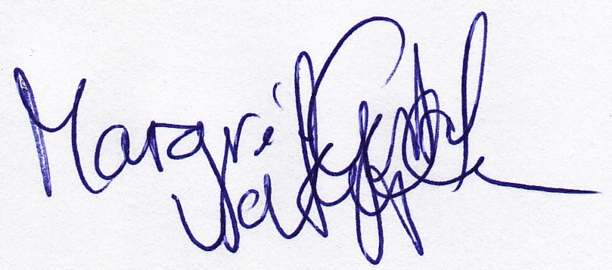

Margré van Gestel v_gestel@hotmail.com

